DAY 1 26 September 2023

**Popups and Window methods**

A popup is a separate window with its own independent JavaScript environment.

A popup can navigate (change-url) and send a message to the opener window.

Window open

The syntax to open a pop is window.open(url,nama,params)

url:

An URL to load into the new window.

Name:

A name of a new window.

Params:

The configuration string for the new window and it contains setting, delimited by comma. Params contain no spaces in between for example: width:200,height=100.

**Closing a Popup**

To close a window we simply write win.close().

To check if a window is closed: win.closed.

The close property is true if the window is closed. That is useful to check if the popup or the main window is still open or not. A user can close it anytime.

**Scrolling and Resizing**

For this type of information, we can use the root document element document.documentElement, that corresponds to the <html> tag. But there are additional methods and peculiarities to consider.

win.moveBy(x,y)

Moves the window relative to current position x pixels to the right, y pixels down. Negative values are also allowed (to move left/up).

win.moveTo(x,y)

Move the window to coordinates (x,y) on the screen.

win.resizeBy(width,height)

Resize the window by given width/height relative to the current size. Also negative values are allowed.

win.resizeTo(width,height)

Resize the window to the given size

Only popups

When preventing an abuse, the browser usually blocks these methods. They only work reliably on popups that we opened, that also have no additional tabs.

No minification/maximization

JavaScript has no way to minify or maximize a window.

Move/resize methods do not work for maximized/minimized windows.

Elem.scrollintoView(top=true)

Scroll the window to make elem show up at the top or at the bottom for elem.scrollIntoView(false).

**Width/height of the window**

To get window width and height, we can use the clientWidth/clientHeight of document.documentElement:

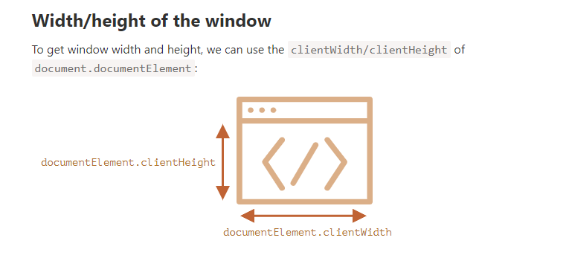

**Focus/Blur on a window**

There are window.focus() and window.blur methods to focus/unfocus on a window. Focus/Blur events allow to focus a window and catch the moment when the visitor switches elsewhere.

When a user attempts to switch out of the window (blur), it brings it back to focus. The intention is to “lock” the user within the window.